To understand NMR you need to know the following:

A. Physics: Moving charge generates a magnetic field, and a moving magnetic field causes charges to move in a conductor.

B. Atomic nuclei, like electrons, have a quantum mechanical property of "spin". Spin can be thought of as a small magnetic field around the nucleus created as if the positive charge of the nucleus were circulating.

C. NMR, nuclear magnetic resonance, is used to assign structures of organic molecules.

D. We care about the nuclei 1H and 13C since these are commonly found in organic molecules and they have spin quantum numbers of 1/2.

E. Nuclei with spin quantum number 1/2 are quantized in one of two orientations, "+1/2" (lower energy) or "-1/2"(higher energy) in the presence of an external magnetic field, that is, with and against the external field, respectively.

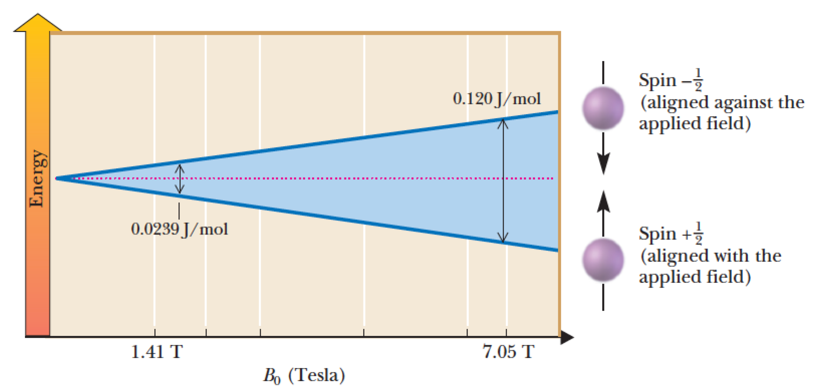

F. **The difference in energy between the +1/2 and -1/2 nuclear spin states is proportional to the strength of the magnetic field felt by the nucleus.**

G. Electron density is induced to circulate in a strong external magnetic field, which in turn produces a magnetic field that opposes the external magnetic field. This **shields** nuclei from the external magnetic field. The greater the electron density around a nucleus, the more shielded it is, and the lower the energy (frequency) of electromagnetic radiation required to flip its nuclear spin.

H. In the classic 1H-NMR experiment, the molecule of interest is placed in solvent (the solvent has deuterium atoms in place of H atoms so the solvent molecules will not show up in the spectra, see R.) then is put in a spinning tube in a very strong magnetic field. The sample is exposed to radiofrequency irradiation and if it is of exactly the right frequency energy is absorbed and spins flip from +1/2 to -1/2 (come into resonance). The absorbed energy is plotted in the spectra.

I. All 1H-NMR spectra are recorded as **chemical shift (∂, delta)** in the units of **ppm** (parts per million). Shielding magnetic field effects are around 1 millionth as large as the external magnetic field in which the sample is placed. Tetramethylsilane (TMS, (CH3)4Si)) is placed in the sample as a standard and assigned the value of 0.0 ppm. ***Warning the NMR scale is plotted “backwards”, with higher values to the left!!***

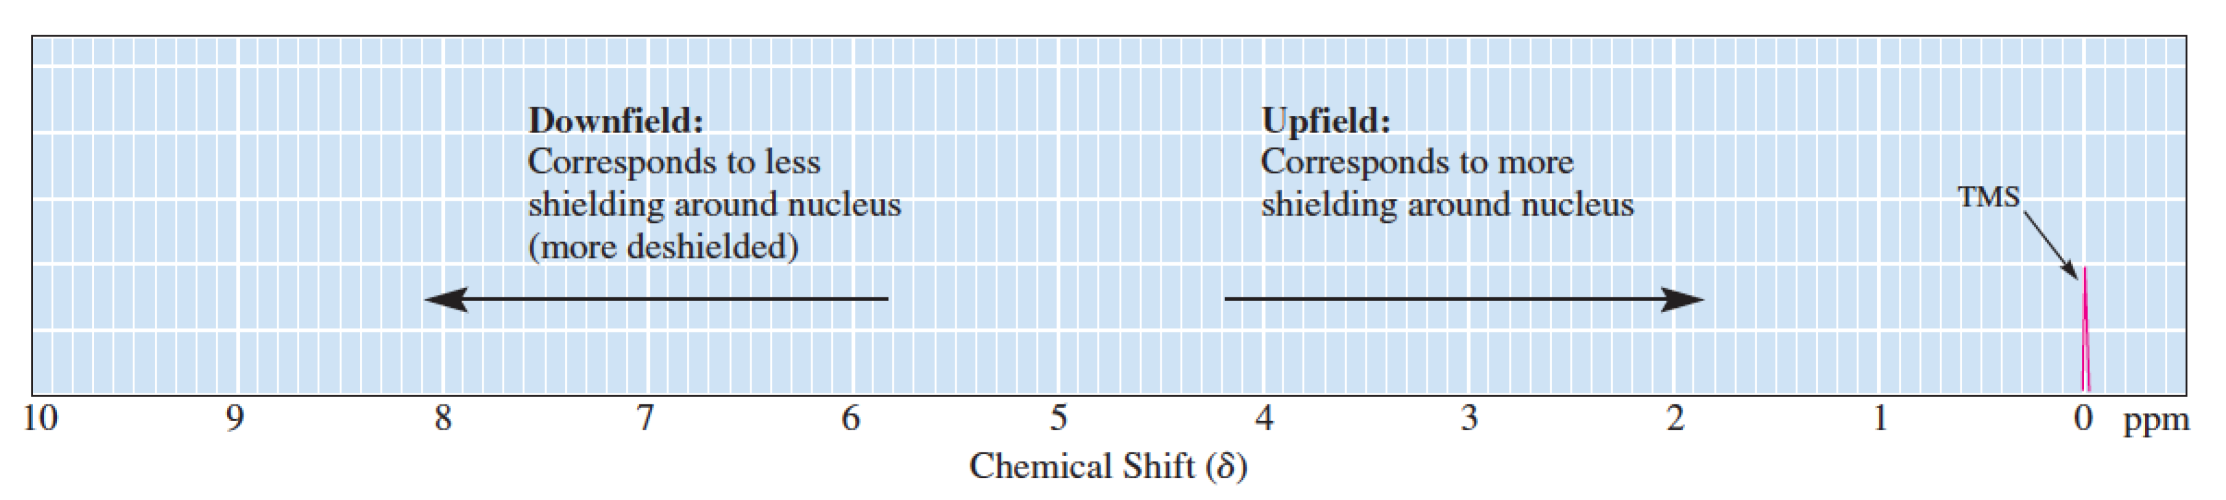

J. The hybridization state of carbon atoms attached to an H atom influences shielding in predictable ways by removing differing amounts of electron density around adjacent nuclei.

K. Electron density in pi bonds also has a large effect on H atom shielding because pi electrons are more free to circulate in an a magnetic field compared to electron density in sigma bonds. Geometry of the pi bond is important.

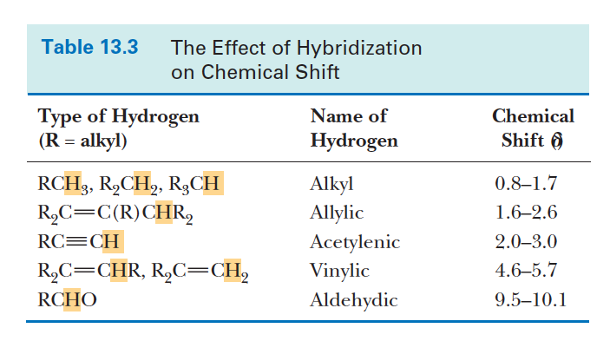

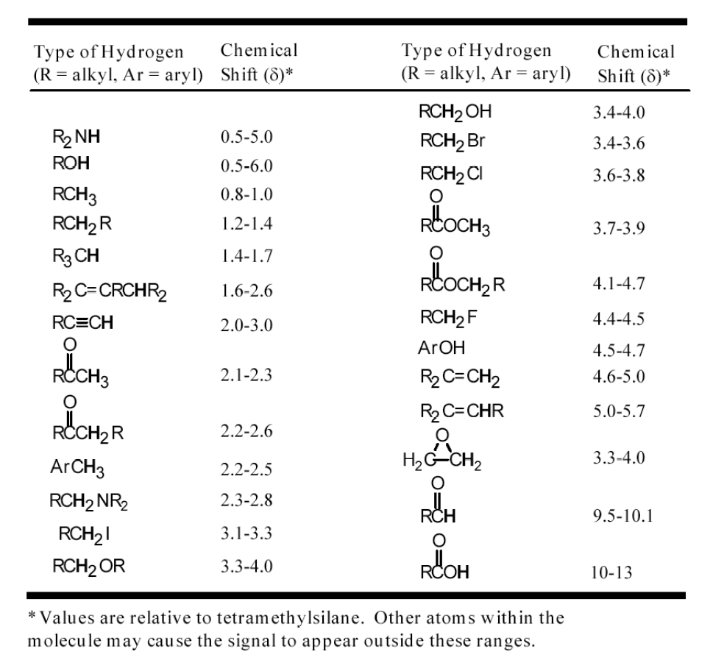

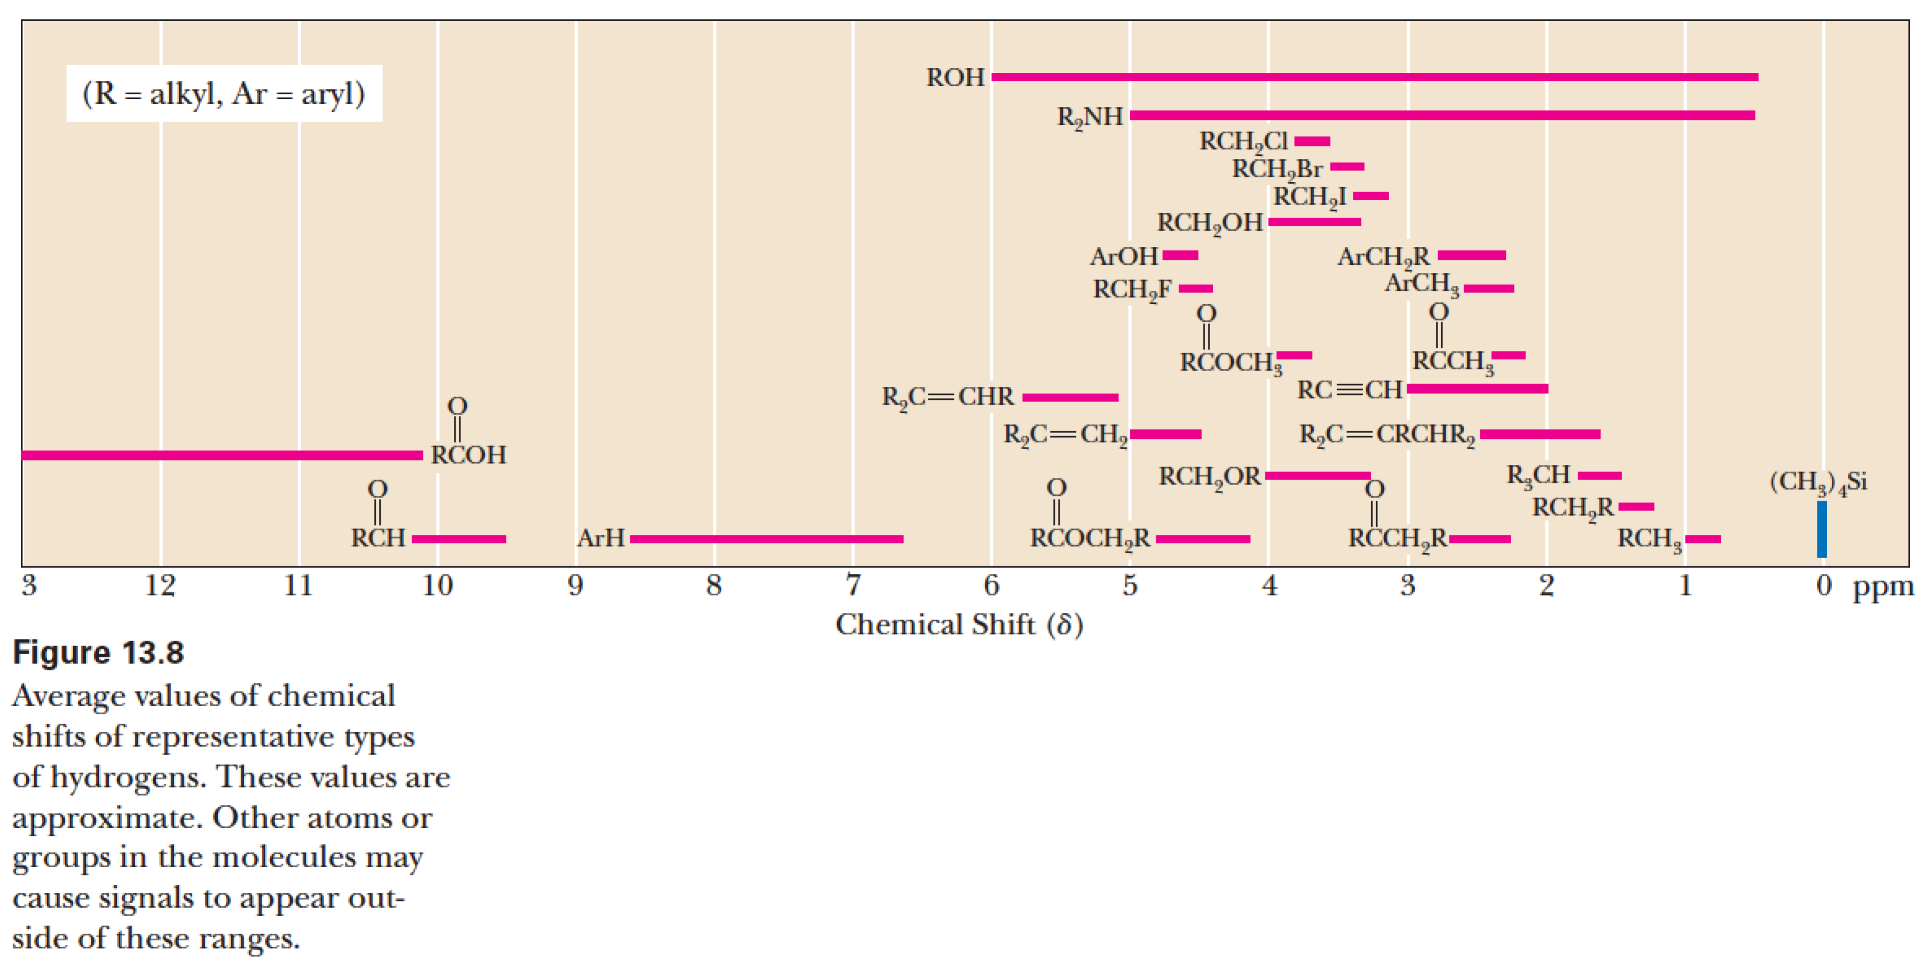

L. Chemically **equivalent** H atoms give rise to the same 1H-NMR signal. **Equivalent** H atoms have the same chemical environment because they are bonded to the same freely rotating *sp3* C atom (molecular motion, nanosecond, is fast compared the time it takes for a spin to flip, microsecond) OR they are equivalent due to symmetry in the molecule.

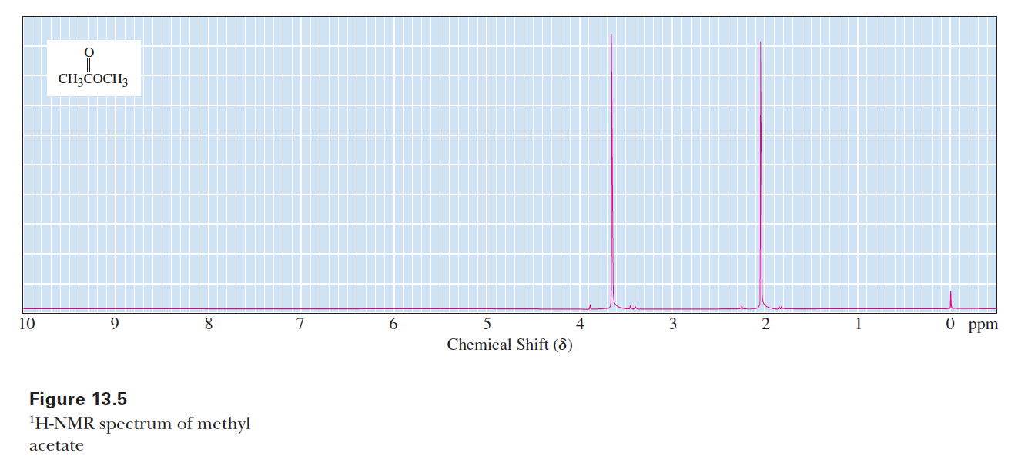

M. The area of a 1H-NMR signal is proportional to the number of equivalent H atoms that give rise to that signal.

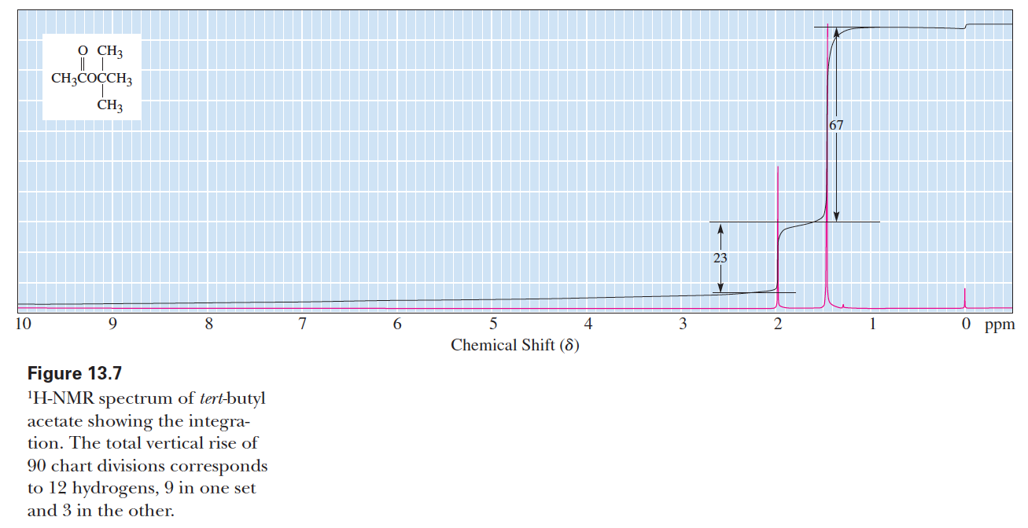

N. Adjacent nuclei have magnetic fields associated with their spins. The spins of equivalent adjacent nuclei can be either +1/2 or -1/2, and at room temperature they are found in about a 50:50 mixture at any given nucleus (very slight excess of lower energy +1/2). These can add to give n+1 different spin **combinations** in the proportions predicted by Pascal's triangle. Each different spin combination produces a different magnetic field, which leads to n+1 splittings in the peaks of the NMR spectra of the adjacent (no more than three bonds away) nuclei.

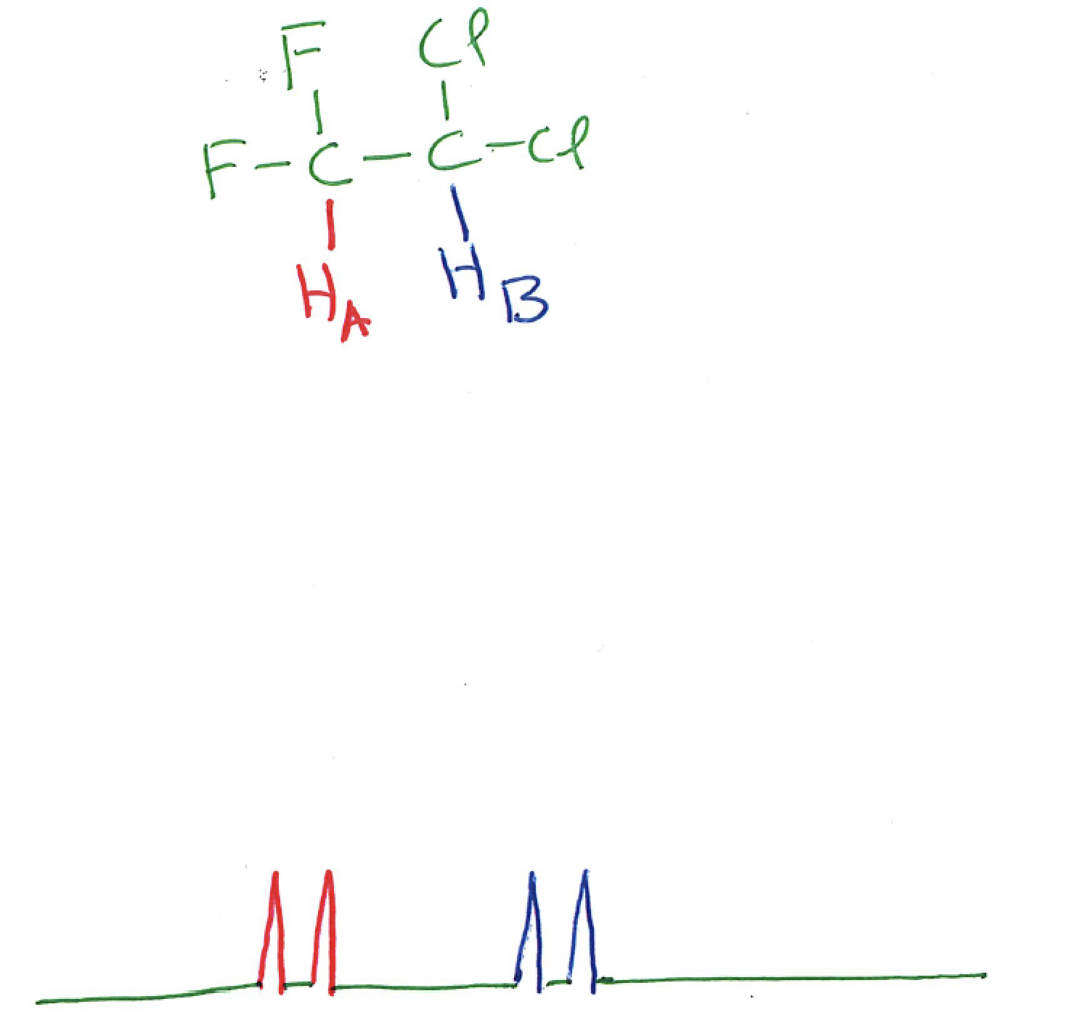

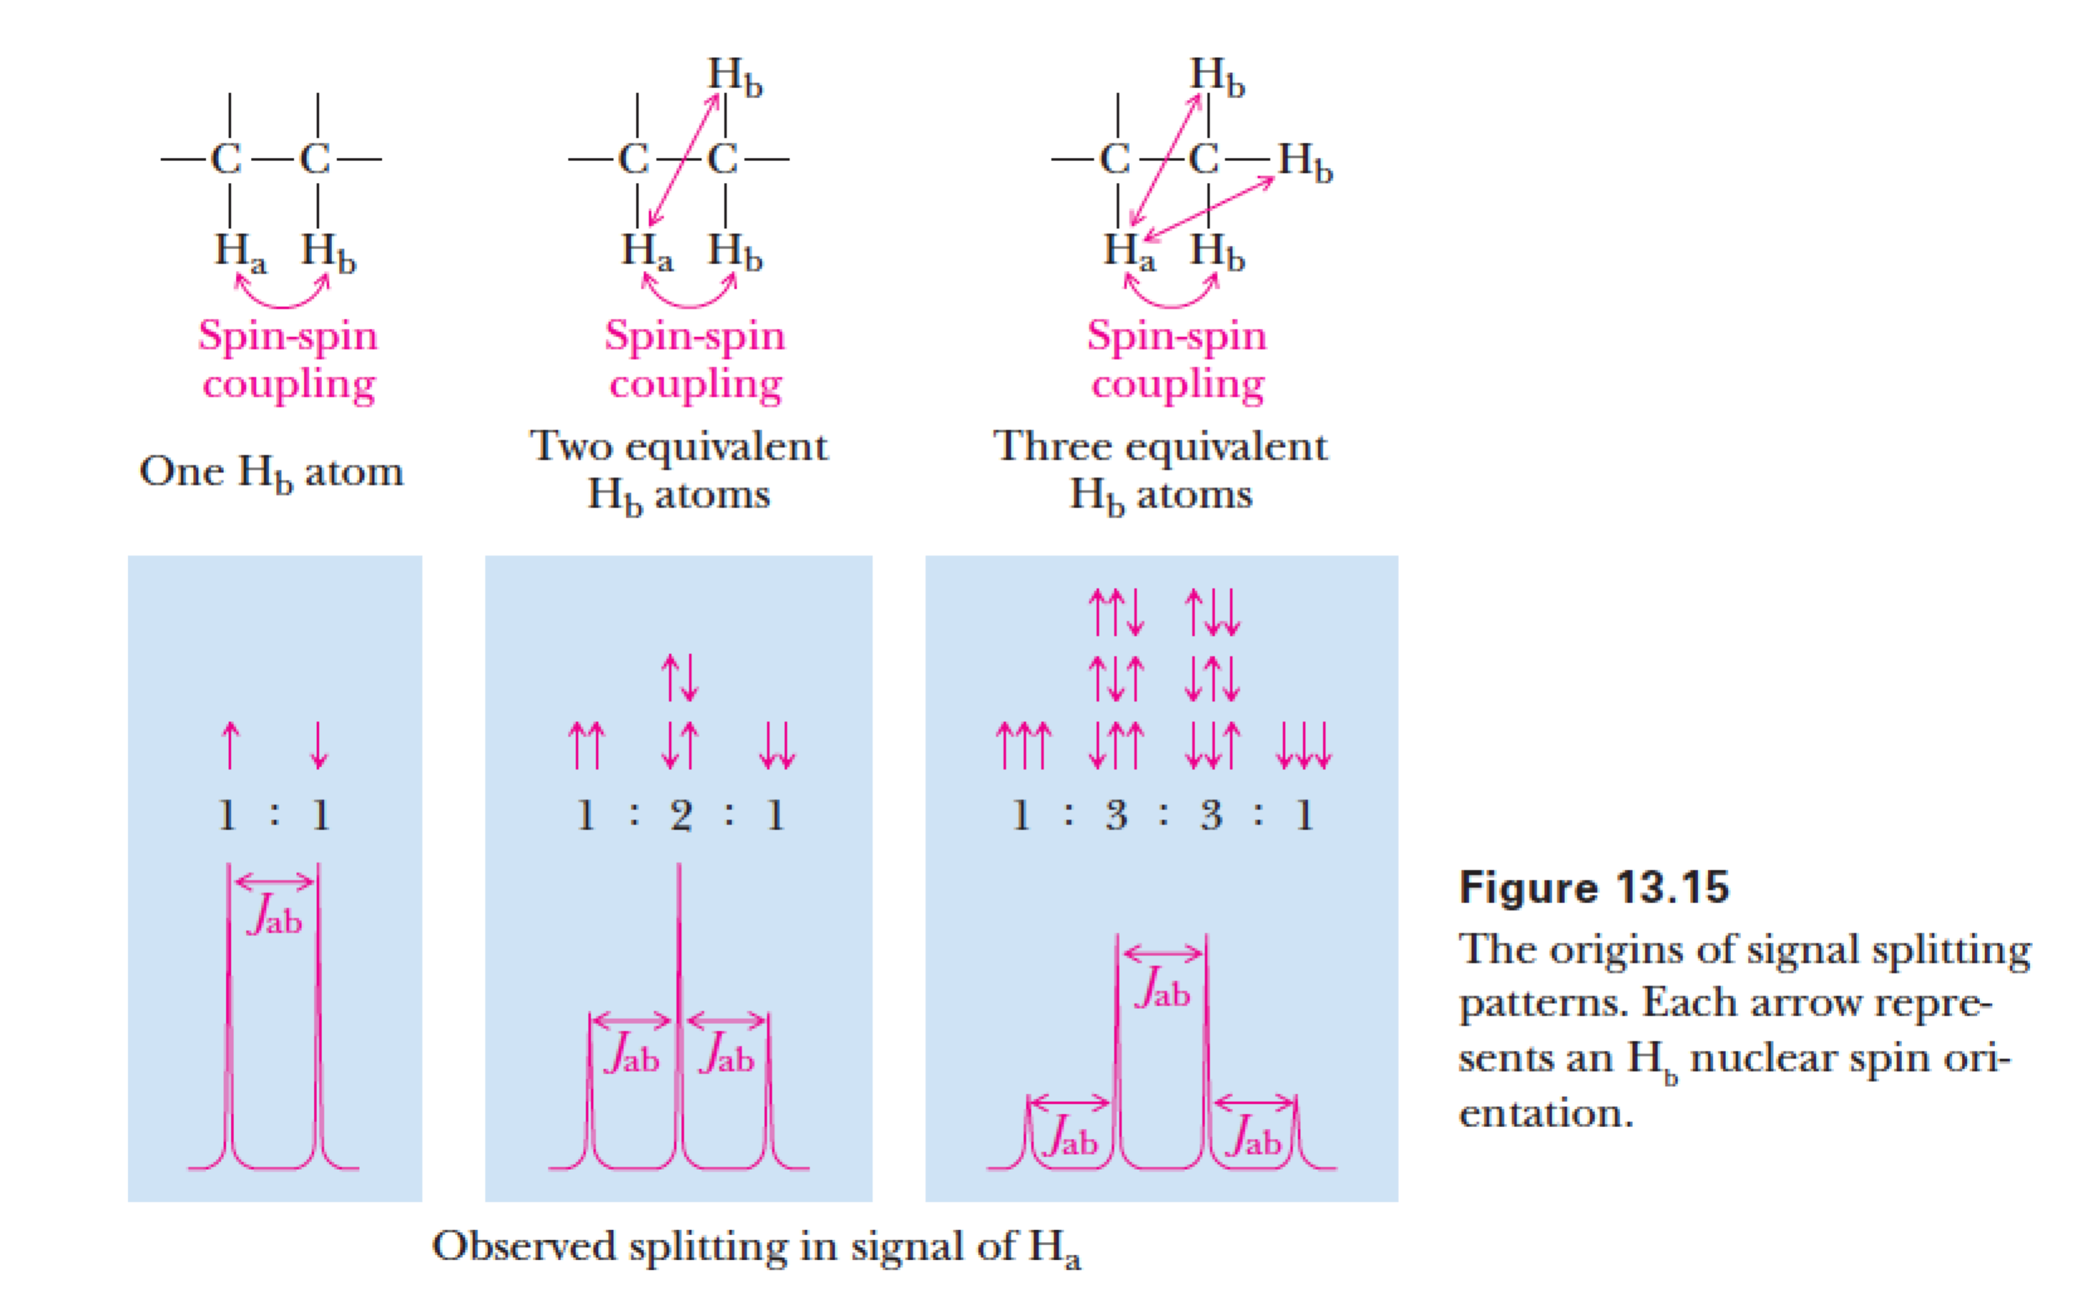

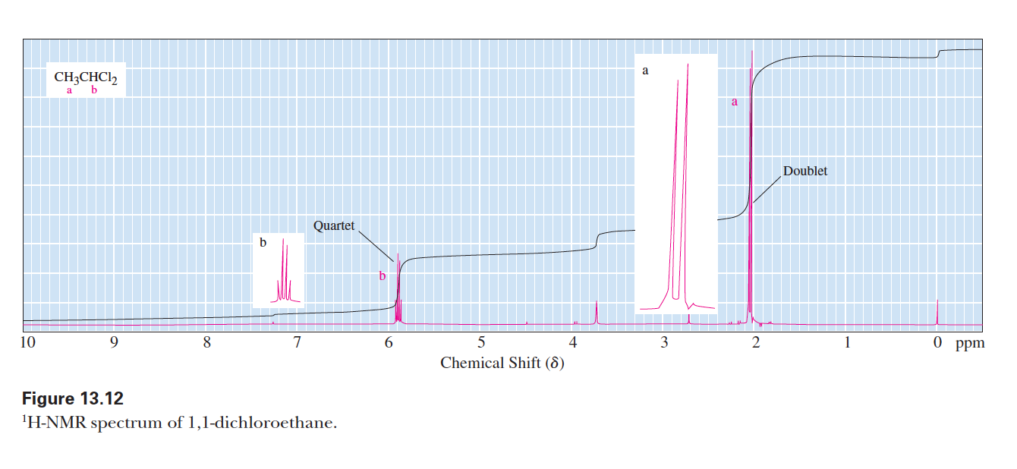

O. THEORY: When there are two sets of adjacent H atoms, the number of peaks multiply. For example, a CH2 group with a CH2 group and a CH3group on either side should show 3 x 4 = 12 splittings! You can say this group is a "triplet of quartets" (or a "quartet of triplets").

P. WHAT YOU WILL SEE IN REALITY : For alkyl groups complex splittings simplify because coupling constants ("J") are all about the same. In practice, if there are n adjacent H atoms, equivalent or not, you will see n+1 peaks. This is an approximation, but almost always true on spectra taken with all but the most sophisticated NMR spectrometers.

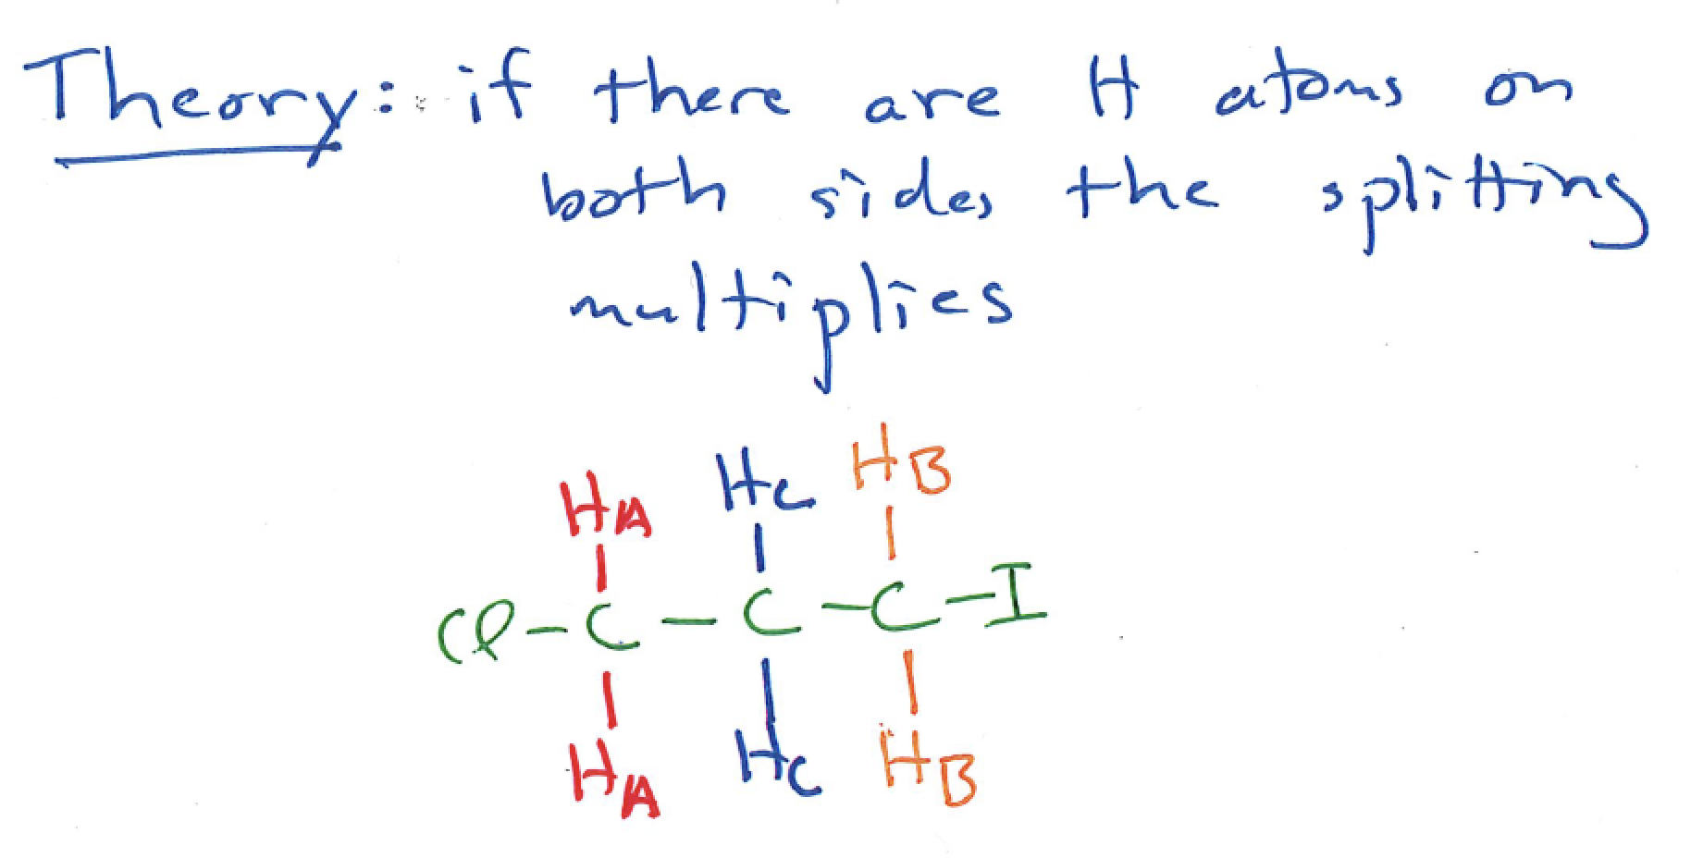

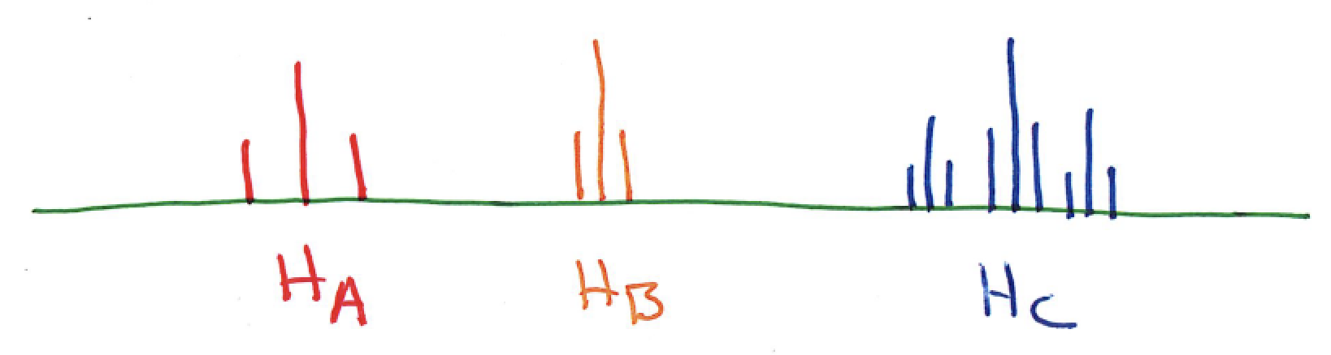

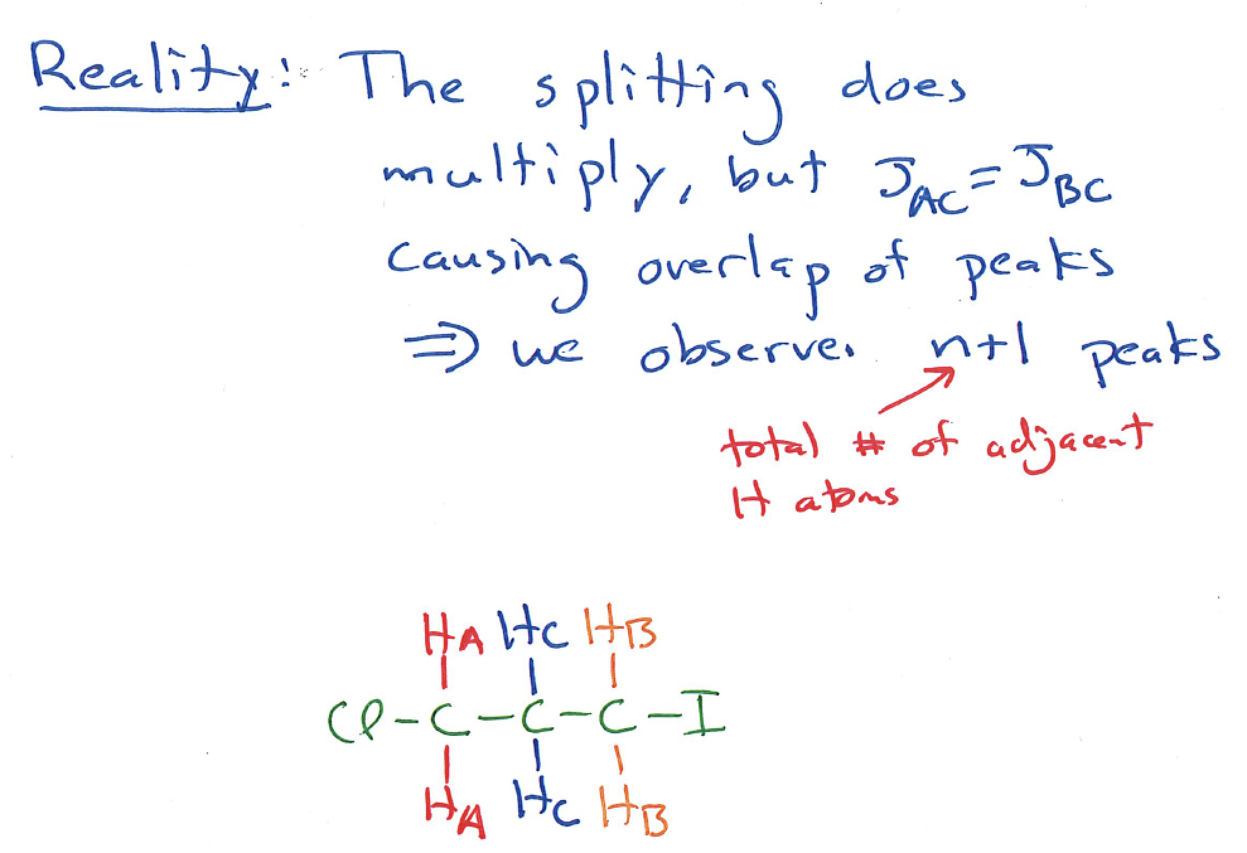

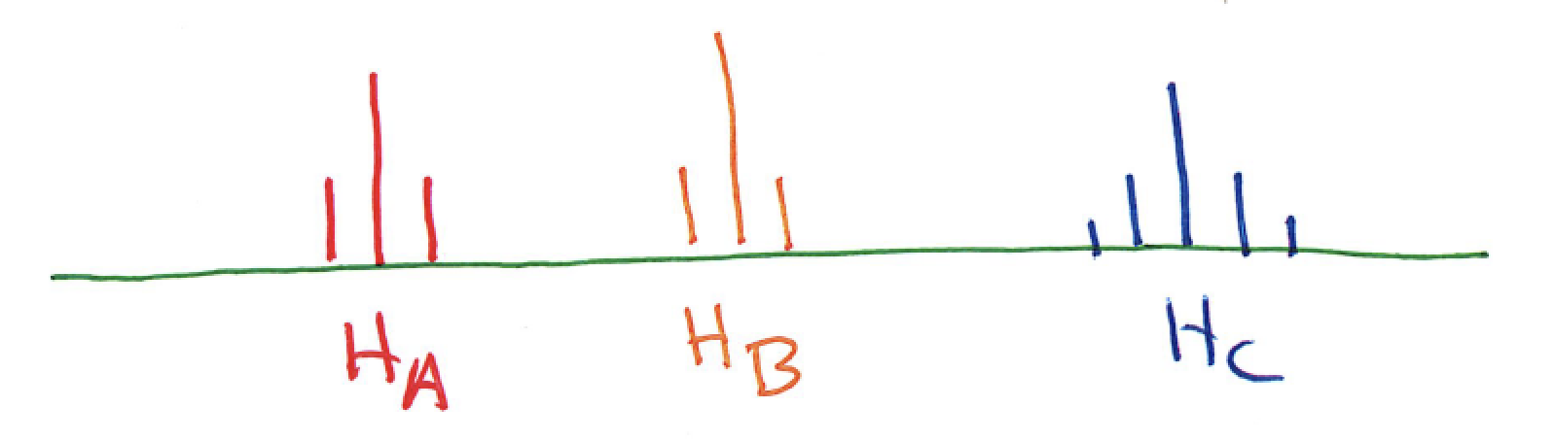

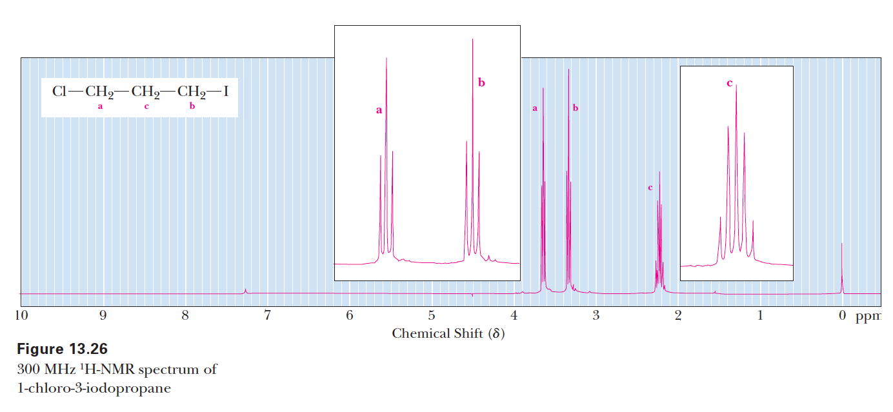

Recap:

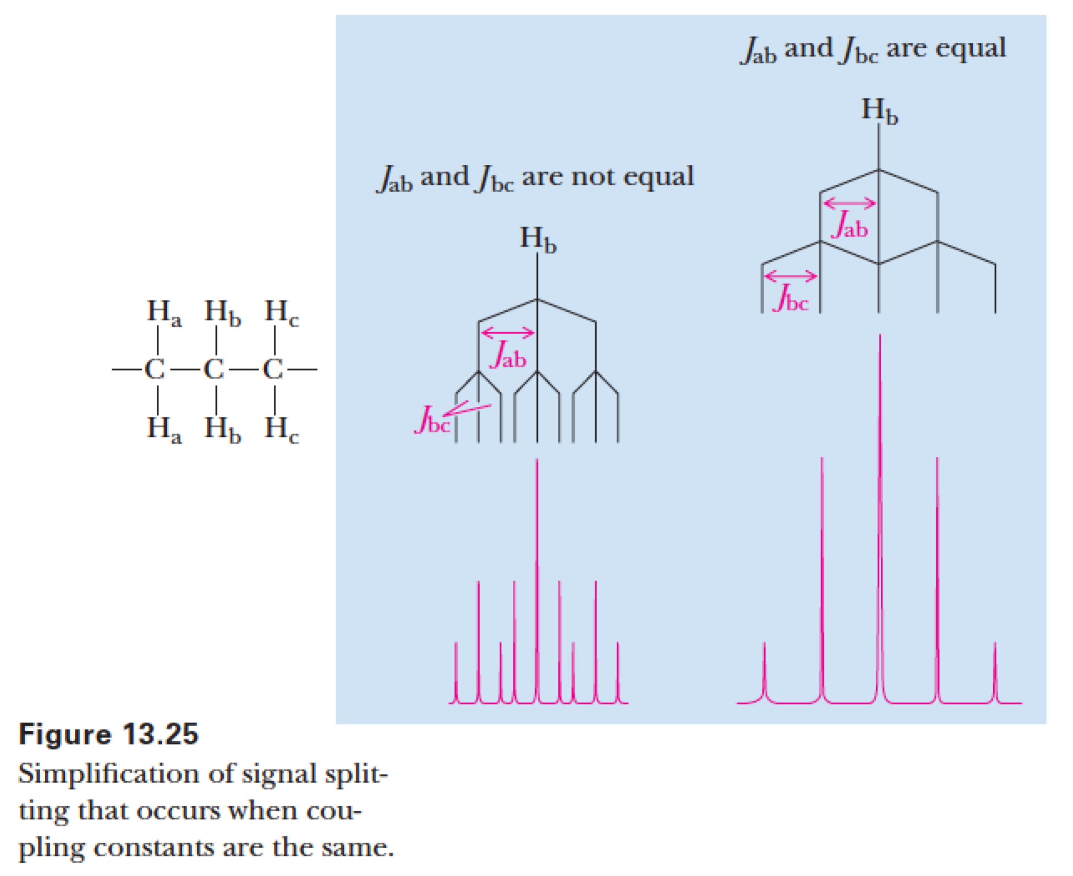

Q. Non-equivalent H atoms on the same C atom can split each other (called geminal coupling), for example on alkenes or small rings. This coupling usually has very small coupling constants, so is difficult to see on some spectra.

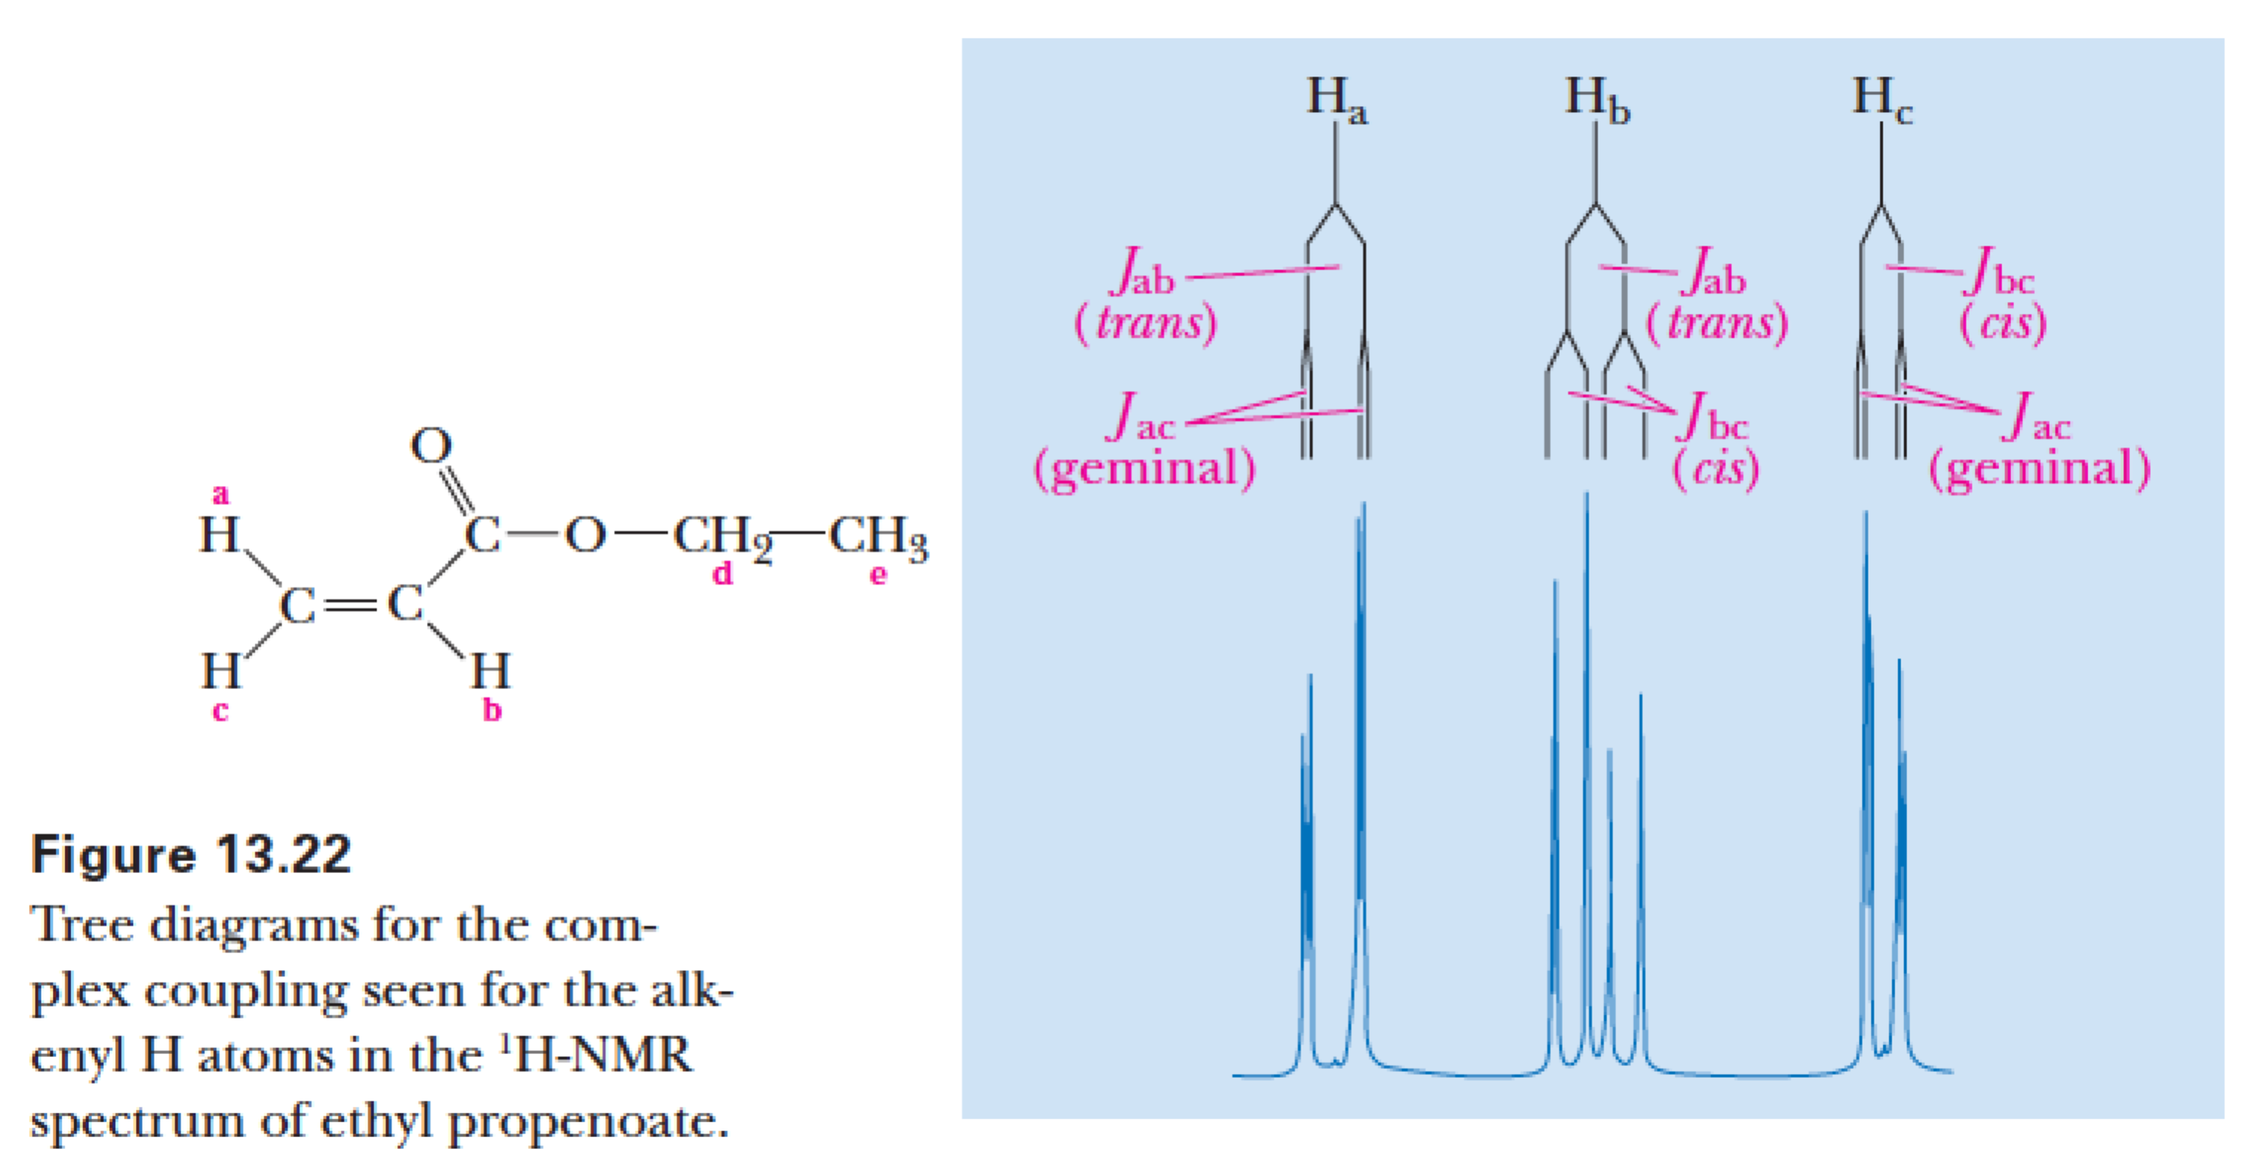

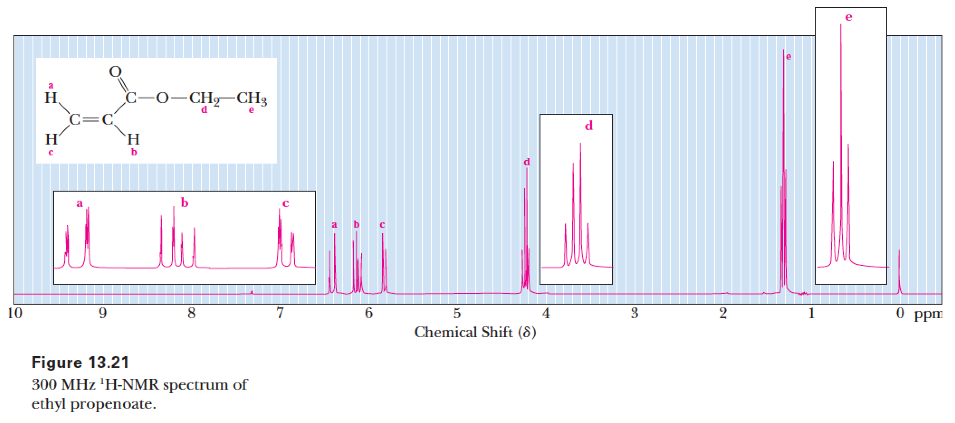

R. Deuterium atoms do not show up in 1H-NMR spectra, so deuerated solvents are used to dissolve NMR samples.

S. The H atoms of relatively acidic functional groups (alcohols, carboxylic acids, amines) exchange rapidly, so they often do not split adjacent protons, and they can be replaced (signal disappears) with deuterium by adding a drop of D2O to the NMR sample.

T. H-bonding changes the location of a signal for H-bonding groups in a concentration dependent manner explaining why -OH and -NH2 group signals can vary so much in location.

U. The splitting of a -CH2- group adjacent to a chiral center will be "messed up", that is split into many peaks. This is useful for identifying chiral centers in molecules.

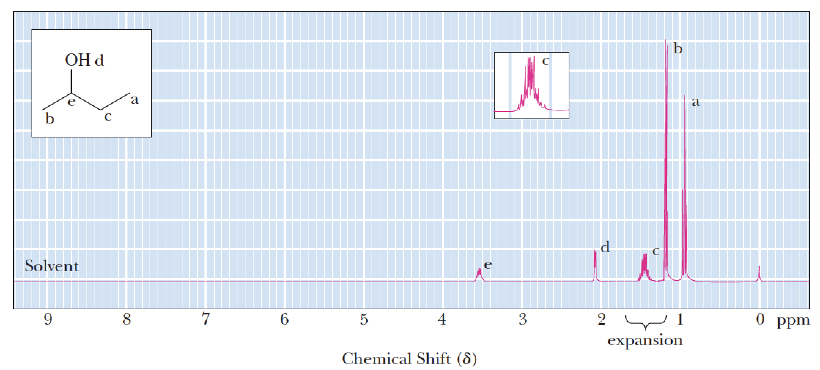

**V. When solving NMR spectra problems:**

**1) Determine number and relative integrations of signals predicted for a given structure**

**2) Make sure the splitting pattern matches with the spectrum for each signal and**

**3) If the number and relative integrations as well as splitting patterns match with the spectra, compare expected chemical shifts with those of the signals in the spectra.**







W. The old way to carry out an NMR experiment: Scan wavelengths (ex. High to low ppm) of radiofrequency electromagnetic radiation then measure absorbance during the scan. This is NOT used any more.

X. What we did not tell you: After a nuclear spin is flipped back from +1/2 to -1/2, it will relax back to the +1/2 spin state and EMIT a photon of the same wavelength it absorbed in the first place.

Y. How modern NMR works:

Z. The Fourier transform converts the emitted photon data into component wavelength and intensity information that is plotted on the ppm scale.