A common situation, and the one many resonance contributing structures describe, occurs when three 2p orbitals combine on adjacent atoms. A good example is the carboxylate anion. When three adjacent 2p orbitals interact (we add the three 2p orbital wave functions ), three new molecular orbitals are produced; a low energy bonding “pi-way”, a non-bonding orbital and an antibonding orbital as shown below. This pattern of three molecular orbitals is generally the same whenever three 2p orbitals interact even if there are different atoms involved, for example the enolate ion or allyl cation. There are four electrons in the pi system of the carboxylate anion, (you can see this by looking at either of the contributing structures; two electrons from the pi bond and two from the third lone pair on the negatively charge O atom). Note the non-bonding orbital contains the electron density of two electrons that are paired, do NOT think of it as having one upaired electron on each O atom. I know, weird, but remember it is best to think of bonding electrons as waves, not particles. Note the electron density on only the O atoms of the non-bonding orbital explains why the negative charge is localized on the O atoms in the carboxylate anion.





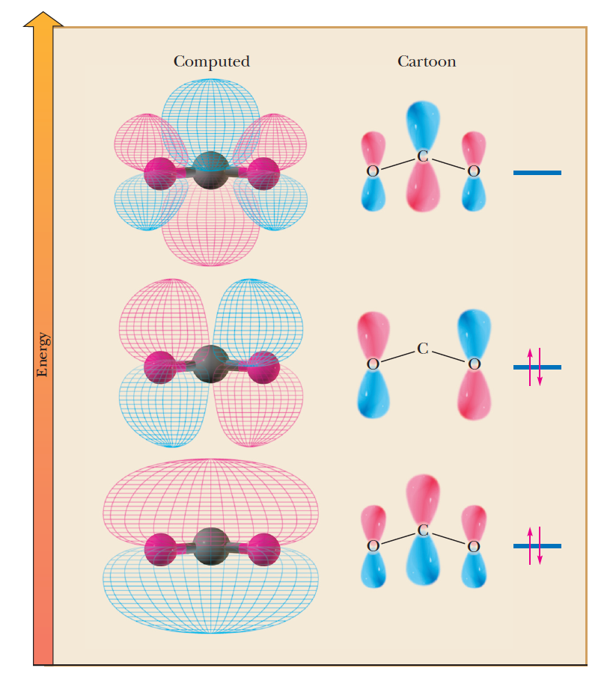

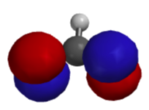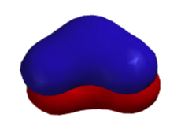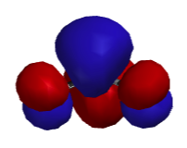

Antibonding orbital

Non-bonding

orbital

“π-way” orbital

Macintosh HD:BLI Backup:6 Classes:CH320M328M Website :Handouts:AlkaneNomenclature.pdf