More NMR Essentials:

N. Non-equivalent H atoms on the same C atom can split each other (called geminal coupling), for example on alkenes or small rings. This coupling usually has very small coupling constants, so is difficult to see on some spectra.

O. Deuterium atoms do not show up in ¹H-NMR spectra, so deuerated solvents are used to dissolve NMR samples.

P. The H atoms of relatively acidic functional groups (alcohols, carboxylic acids, amines) exchange rapidly, so they often do not split adjacent protons, and they can be replaced (signal disappears) with deuterium by adding a drop of D₂O to the NMR sample.

Q. H-bonding changes the location of a signal for H-bonding groups in a concentration dependent manner explaining why -OH and -NH₂ group signals can vary so much in location.

R. The splitting of a -CH₂- group adjacent to a chiral center will be "messed up", that is split into many peaks. This is useful for identifying chiral centers in molecules.
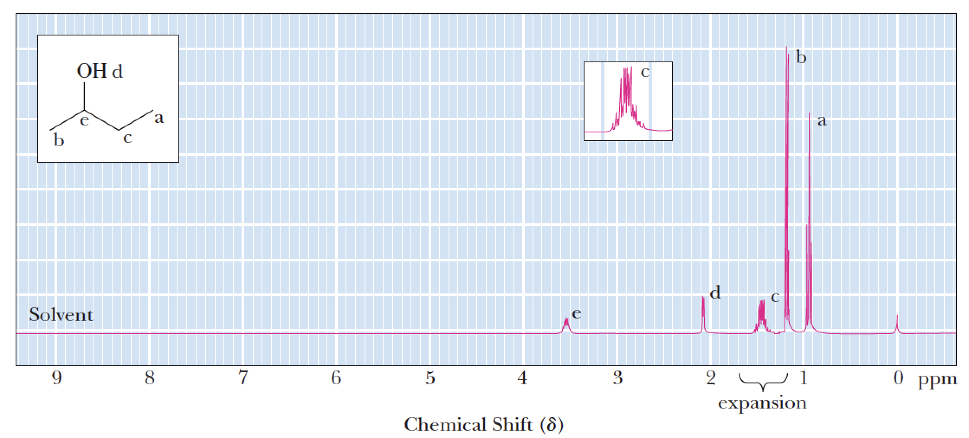

S. When solving NMR spectra problems:
1) Determine number and relative integrations of signals predicted for a given structure
2) Make sure the splitting pattern matches with the spectrum for each signal and
3) If the number and relative integrations as well as splitting patterns match with the spectra, compare expected chemical shifts with those of the signals in the spectra.

