Students Getting Started with OWL in Canvas

- Make Sure Popup Blockers are Disabled. Canvas requires OWL to open in a new Browser window (or Tab). If you are clicking on an OWL link and it appears nothing is happening, it is likely that your Browser’s pop-up blocker is preventing this. Here are instructions for allowing pop-ups in various Browsers: Cengage Pop-up Blocker Instructions.

- Link Your CengageBrain Account. The first time you click on a MindTap link, you will be prompted to link your CengageBrain account with your campus Learning Management System account (one-time only). If you do not have a CengageBrain account, you must create one.
- Redeem your Access Code. After you have linked your CenageBrain account you will be prompted to enter your product access code. If you have not yet finalized your purchase, you may access OWL for a trial period. Any and all work you perform in OWL will be saved during this period, but access will discontinue after the trial expiration date, until you redeem a valid access code.

- After logging into OWL, Run a System Check using the icon in the upper right corner to make sure you will have the optimal experience in OWL:
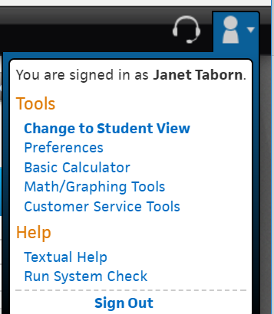
- Technical Support. Use the Cengage Technical Support link in your Canvas course to submit a ticket. This will send the information about your course and product in use to the technicians. Be sure to describe your issue in as much detail as possible, and attach a screen shot of the entire page, including the URL. This will allow tech support to solve your problem faster. Tech support will likely want to know your browser and version, which can be found at www.whatismybrowser.com (this will also tell you if you have the latest versions of Java and Flash, which are often required). Once you create a case, you will be given a case #. If your case is not resolved within 24 hours, send your case # to your instructor and it will be escalated.

