Purchasing Courseware through IA Bookshelf

1. 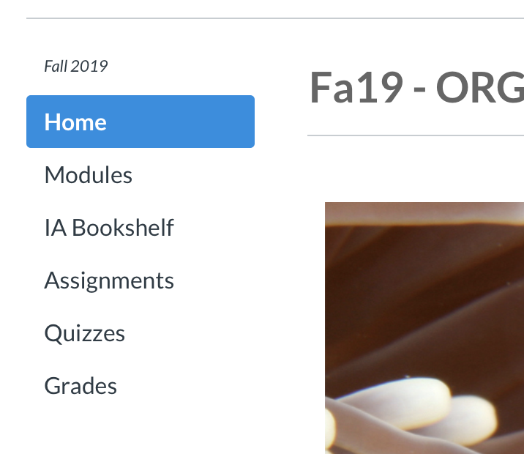Click on the “IA Bookshelf” tab on your course Canvas site.



1. Click Buy Now to purchase your low-cost redemption code.

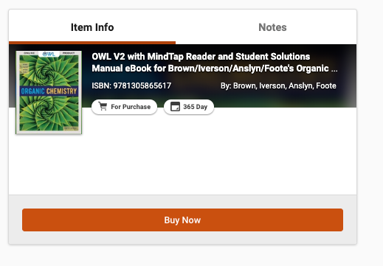

1. Click “Begin Checkout”

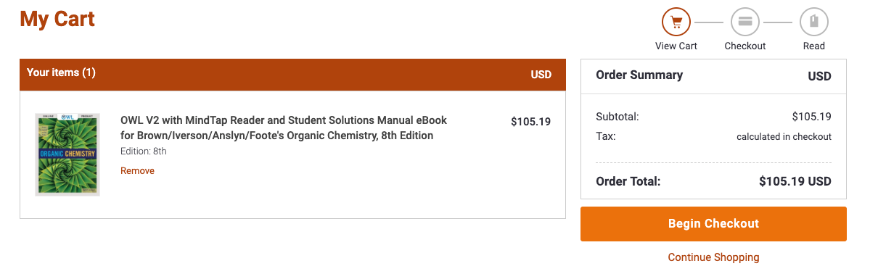

1. Once the check-out has been completed you will be able to access your course materials.

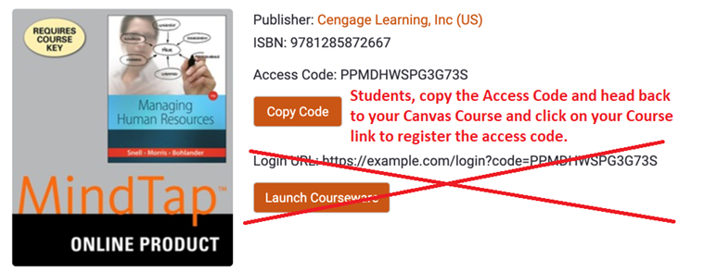

1. To register click on:

“Modules” (on the left side menu under “Home”) then click on:

“[Click here first to access your course resources (text eBook and Solutions Manual)](https://utexas.instructure.com/courses/1257354/modules/items/9532896)”

Then you should see:

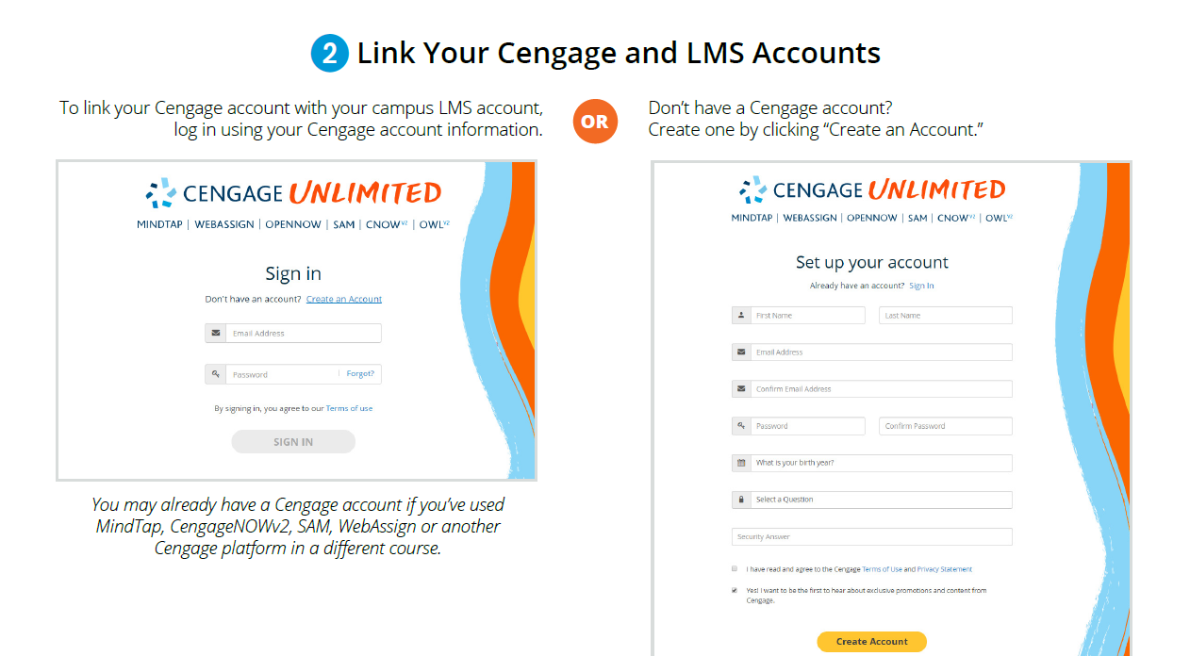

Create you Cengage Account and apply your access code.

1. After you have registered everything and entered your access code, every time you want to access your eBook click on:

“Modules” (on the left side menu under “Home”) then click on:

“eBook for Iverson CH320M/328M BrownIversonAnslynFootes Organic Chemistry“

Be sure to check out the Student Solutions eBook that has detailed answers with explanations for each end of chapter problem in the eBook. Previous students have found this extremely helpful.

“[Student Solutions eBook for BrownIversonAnslynFootes Organic Chemistry](https://utexas.instructure.com/courses/1257354/modules/items/9532903)”