Understanding (as opposed to memorizing) mechanisms is critical to mastering organic chemistry. Although the mechanisms you encounter throughout the course may seem entirely different, they are actually related in fundamental ways. In fact, almost all of the organic reaction mechanisms you will learn are composed of only a few different individual elements (steps) that are put together in various combinations. Your job is to learn these individual mechanism elements, and then understand how to assemble them into the steps of the correct mechanism for the reactions you will see. The KEY idea is that each mechanism step should be thought of as a MULTIPLE CHOICE situation in which you evaluate the structures and reactivities of the molecules involved then rule out inappropriate elements on the way to deducing the appropriate element for each step of the mechanism.

Polar Reaction Mechanisms:
Polar reactions are most of what you will see in organic chemistry, amounting to greater than 95% of cases we will discuss. There are only a few different mechanistic elements that combine to make up the different steps of almost all the mechanisms you saw in CH310M. Better yet, in CH310N the following four mechanistic elements are pretty much all you need to think about until we get to electrophilic aromatic substitution near the end of the semester.

- Make a new bond between a nucleophile (source for an arrow) and an electrophile (sink for an arrow). Use this element when there is a nucleophile present in the solution as well as an electrophile suitable for reaction to occur.

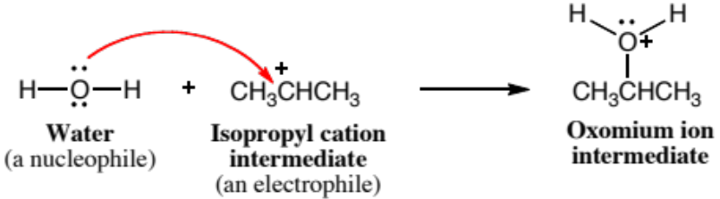

- Break a bond so that relatively stable molecules or ions are created Use this element when there is no suitable nucleophile-electrophile or proton transfer reaction, but breaking a bond can create neutral molecules or relatively stable ions, or both.
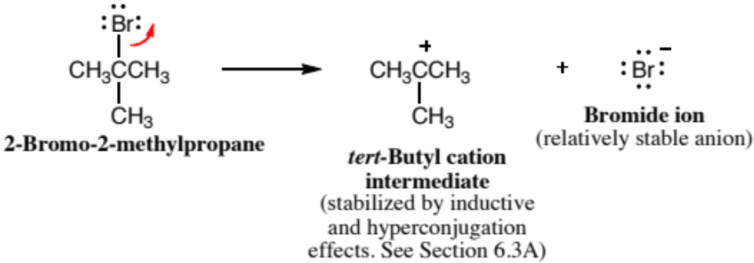

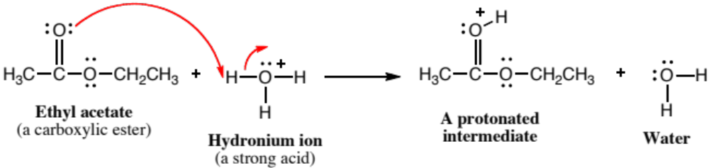
- Add a proton Use this element when there is no suitable nucleophile-electrophile reaction, but the molecule has a strongly basic functional group or there is a strong acid present.

- Take a proton away Use this element when there is no suitable nucleophile-electrophile reaction, but the molecule has a strongly acidic proton or there is a strong base present.

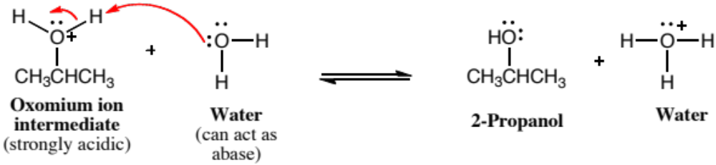

The situation is even simpler than you might expect because 1. and 2. are the functional reverse of each other, as are 3. and 4. in many cases.

Useful Definitions:
Mechanism – A scheme that illustrates all reaction intermediates, as well as the flow of electrons and movement of atoms during bond breaking and bond making processes. Remember that arrows are used only to indicate the movement of electrons. Movement of atoms is assumed, but not explicitly indicated, by the arrows.

Nucleophile – A molecule that contains an atom with a lone pair AND a full or partial negative charge.

Electrophile – A molecule that contains an atom with a full or partial positive charge AND can be attacked by a nucleophile without creating a non-viable species such as a pentavalent (five bonds) carbon.

Base – A molecule containing at least one atom with a lone pair that will accommodate binding to a proton.

Acid – A molecule that can donate a proton.

Leaving group – A group that will be relatively stable when it departs, such as a small neutral species like H₂O or N₂, or a group such as a halide atom that departs as a relatively stable ion.

Putting it All Together:
The preceding discussion can be applied to all of the polar reaction mechanisms you will see in organic chemistry. For example, the following equation describes the conversion of a tertiary alcohol into an alkyl halide under acidic conditions.

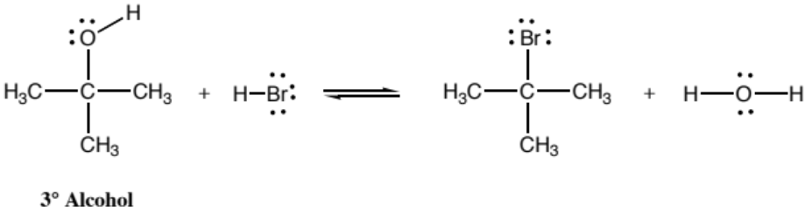

Each step of the correct three-step mechanism for this process can be deduced by choosing the appropriate mechanistic element (1-7) based on the structures and reactivities of the molecules present.

Step 1: Add a Proton - There is no suitable nucleophile-electrophile reaction, the molecule has no good leaving groups, but there is a proton source present in the solution such as a strong acid. The alcohol oxygen atom lone pairs can accept the proton from a strong acid like HBr.

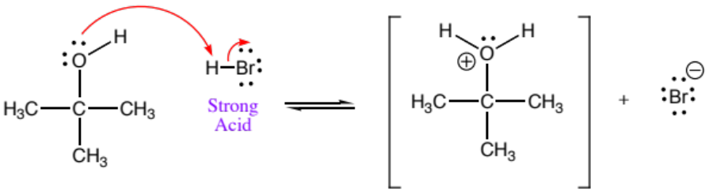

Step 2: Break a bond so that relatively stable molecules or ions are created – There is no suitable nucleophile-electrophile* or proton transfer reaction, but the molecule has a good leaving group attached.

*There is no suitable nucleophile-electrophile reaction despite the presence of a good leaving group and a good nucleophile (Br ⁻) in the solution because of the steric hindrance caused by the three methyl groups around the tertiary carbon atom, preventing a backside attack required for an S_{N}2 reaction.

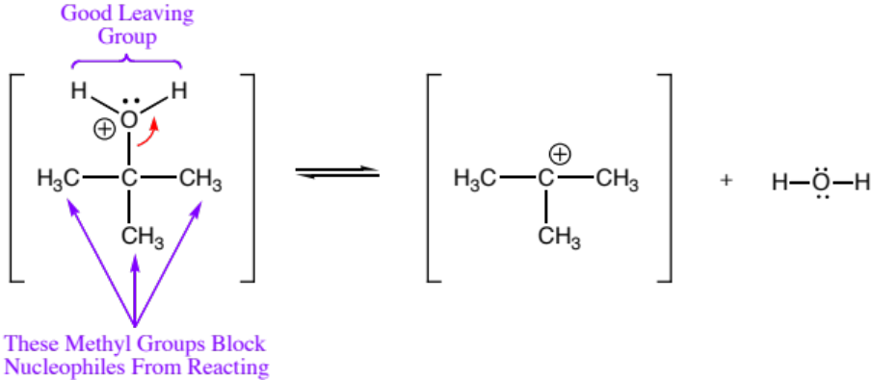

Step 3: Make a new bond between a nucleophile and an electrophile – There is a nucleophile present in the solution (water) and the molecule has an electrophilic atom (an atom with a positive charge). The nucleophile-electrophile reaction takes place because the electrophilic carbon atom is sp² hybridized (trigonal planar geometry), and the Br ⁻ can approach from either the top or bottom without interference from the methyl groups.

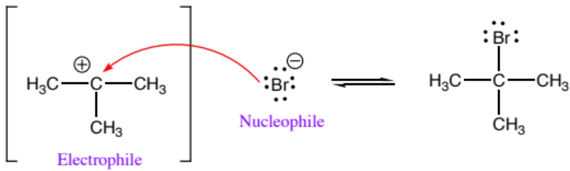

END OF MECHANISM

Note that steps 2 and 3 above correspond to an S_{N}1 mechanism, and that E1 was suppressed in this case because of the presence of the strong acid (never have a step involving base when the reaction is run in acid). Sometimes to save space, mechanisms are written in a more condensed format such as the following:

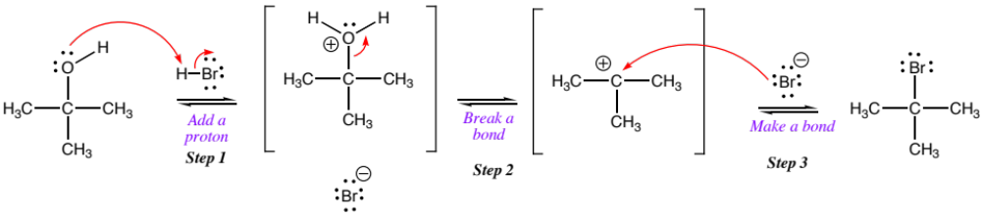

In second semester organic chemistry, the mechanisms get more complicated, but not the multiple choice type of analysis used to deduce appropriate mechanism elements for each mechanism step. For example, the following equation describes the acid-catalyzed hydrolysis of an acetal to give an aldehyde and two equivalents of alcohol.

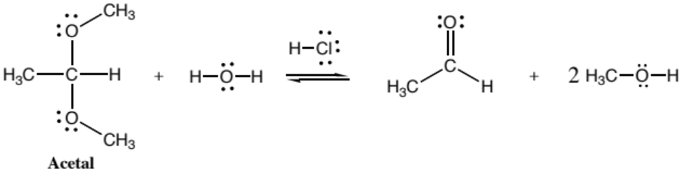

The following seven-step mechanism for acetal hydrolysis may look complicated, but it is actually a relatively straightforward sequence of mechanism elements 1-4 that can be deduced by analyzing each step according to the structures and reactivities of the molecules present.

Step 1: Add a Proton - There is no suitable nucleophile-electrophile reaction, the molecule has no good leaving groups, but there is a proton source present in the solution such as a strong acid.

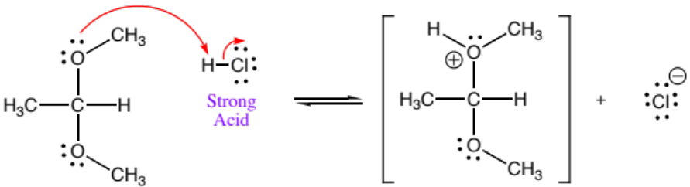

Step 2: Break a bond so that relatively stable molecules or ions are created – There is no suitable nucleophile-electrophile or proton transfer reaction, but the molecule has a good leaving group attached.

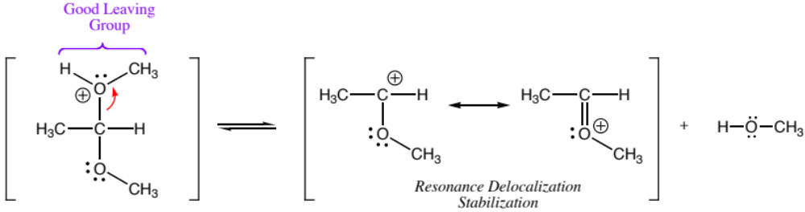

Step 3: Make a new bond between a nucleophile and an electrophile – There is a nucleophile present in the solution (water) and the molecule has an electrophilic atom (an atom with a positive charge).

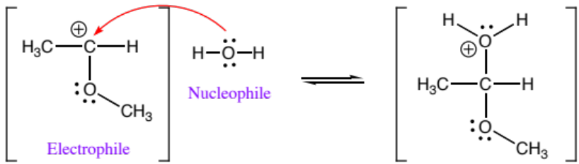

Step 4: Take a Proton Away – There is no suitable nucleophile-electrophile reaction, but the molecule has an acidic proton.

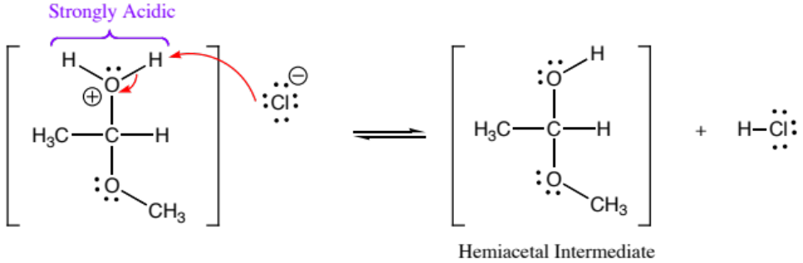

Note that the H₂O group is a good leaving group as well as being strongly acidic, but having it depart would simply reverse the previous step, so that is not a productive choice.

Step 5: Add a Proton - There is no suitable nucleophile-electrophile reaction, the molecule has no good leaving groups, but there is a proton source present in the solution such as a strong acid.

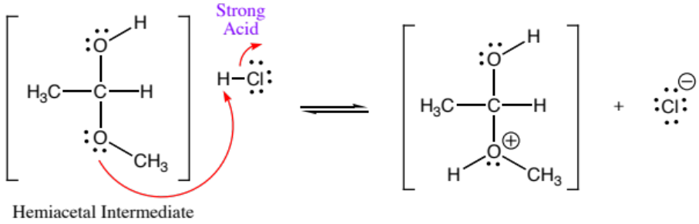

Step 6: Break a bond so that relatively stable molecules or ions are created – There is no suitable nucleophile-electrophile or proton transfer reaction, but the molecule has a good leaving group attached.

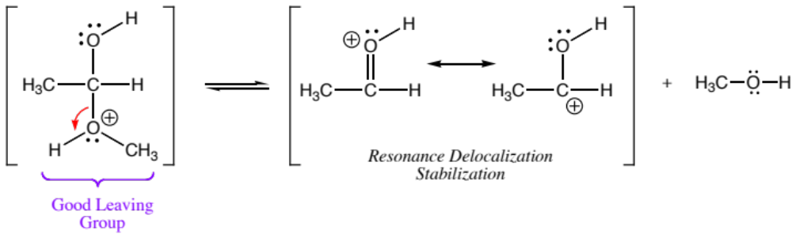

Note that the CH₃OH group is strongly acidic as well as being a good leaving group, but taking a proton away would simply reverse the previous step, so that is not a productive choice.

Step 7: Take a Proton Away – There is no suitable nucleophile-electrophile reaction, the molecule has no good leaving groups, but it has an acidic proton.

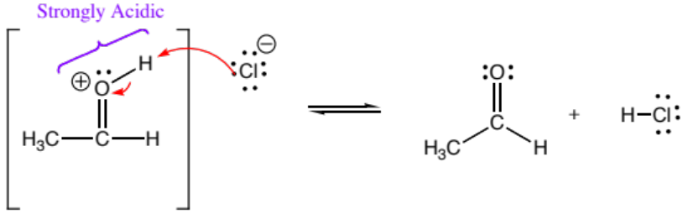

END OF MECHANISM

Complex mechanisms such as this are often written in one of several condensed formats. Here is one such format:

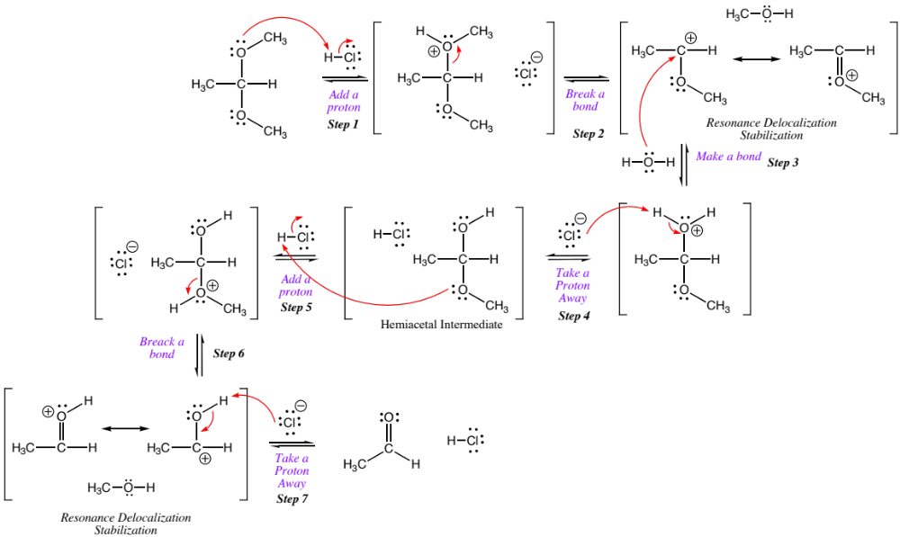

An alternative condensed format is linear:



