In the classic ¹H-Nuclear Magnetic Resonance (¹H-NMR) experiment:
- A sample of the molecule of interest is placed in solvent (the solvent has deuterium atoms in place of H atoms so the solvent molecules will not show up in the spectra.
- The solution is put in a spinning tube in a very strong magnetic field.
- The sample is exposed to radiofrequency irradiation and if it is of exactly the right frequency, energy is absorbed and spins flip from +1/2 to -1/2 spin states (the energy absorption/spin flipping process is called resonance).
- The absorbed energy is plotted on the spectra as a function of wavelength, normalized by using the parts per million (ppm) scale.
- ¹H nuclei in different functional groups come into resonance at different and characteristic values of ppm and adjacent ¹H nuclei split signals in predictable ways, allowing for chemical structures to be determined based on ¹H NMR spectra.

The old way to carry out an NMR experiment:
- Scan wavelengths (ex. High to low wavelengths) of radiofrequency electromagnetic radiation.
- Measure absorbance during the scan and plot the amount of energy absorbed versus wavelength using the normalized ppm scale.
- This is NOT used any more.

What we did not tell you: After a nuclear spin is flipped back from +1/2 to -1/2, it will relax back to the +1/2 spin state and EMIT a photon of the same wavelength it absorbed in the first place.

How modern NMR works:
- The sample is irradiated with all wavelengths simultaneously with a short blast. All of the ¹H spins are flipped at once.
- The sample is monitored for emitted photons as the ¹H nuclear spins “relax” back to the +1/2 spin state.
- The emitted photons are analyzed using a technique called Fourier Transform (FT) to extract frequency and intensity information.
- The frequency and intensity information is plotted on the ppm scale.
- This process is repeated hundreds or thousands of times with the same sample to dramatically improve signal-to-noise.

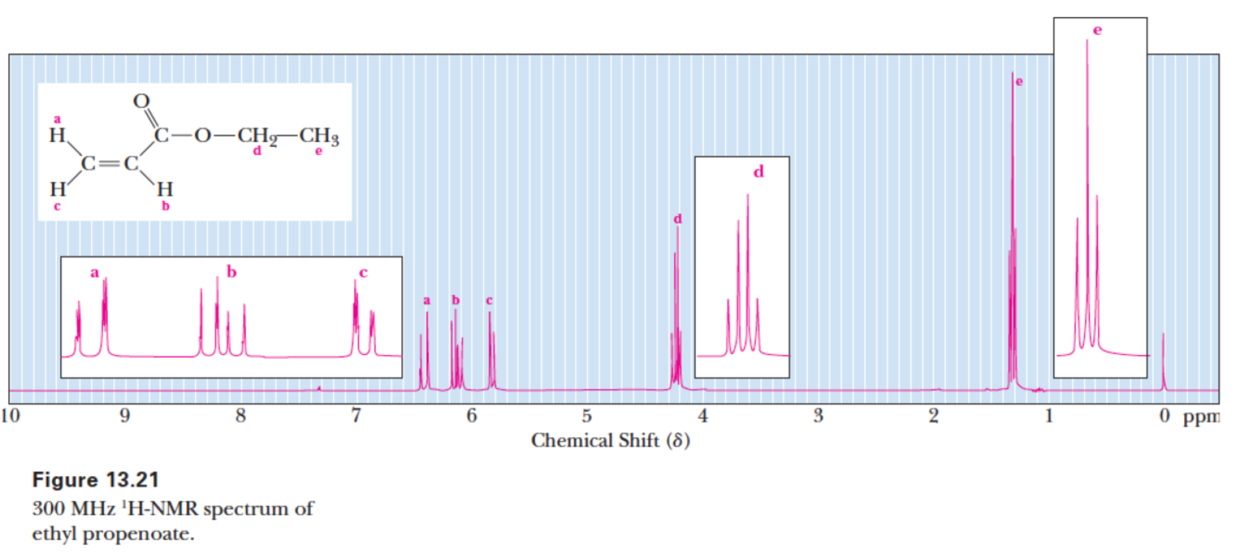

MRI – Nuclear Magnetic Resonance Imaging – Produces a 3-d image inside the body.

MRI is similar in approach, but complementary to, a CAT scan, which uses X-rays for imaging.

MRI is therefore safer than a CAT scan (no X-rays or other damaging radiation is used). Radiofrequency electromagnetic radiation does not cause DNA damage or any other kind of damage.

MRI primarily visualizes soft-tissue and especially cancer tumors while a CAT scan primarily visualizes bones or Calcium based dyes drunk to visualize the digestive tract.

MRI uses the same principles and NMR.
- The patient is placed in a very strong magnetic field. Creating this very strong magnetic field is technically very demanding, explaining MRI machines are so expensive (~ 0.5 – 1.5 $ million)
- The patient is irradiated with radiofrequency electromagnetic radiation.
- The flipping (resonance) of ¹H nuclear spins is monitored – Actually emitted photons are measured using the FT method.
- Magnetic field gradients are used to gain imaging information. The magnetic field gradients are rotated around a central point and measurements are taken at each angle around 360° to gain 2-dimensional information. This technique is called tomography.

The overall MRI imaging approach involves looking at each 2-dimensional slice.

Each slice is added to give a 3-dimensional stack (analogous to stacking DVD’s or CD’s).

Each slice is shaded to indicate differences in the amount of ¹H atoms in different areas/tissues.

Water and fat have the highest density of ¹H atoms, so these are primarily being monitored in an MRI image.

The popular medical diagnostic technique of magnetic resonance imaging (MRI) is based on the same principles as NMR, namely the flipping (i.e. resonance) of nuclear spins of H atoms by radio frequency irradiation when a patient is placed in a strong magnetic field. Magnetic field gradients are used to gain imaging information, and rotation of the gradient around the center of the object gives imaging in an entire plane (i.e. slice inside patient). In an MRI image, you are looking at individual slices that when stacked make up the three-dimensional image of relative amounts of H atoms, especially the H atoms from water and fat, in the different tissues [Memorize the preceding passage, as it will be worth 14 points on the next midterm. No I am not kidding, I just gave you 14 points right there.]
