Take Home Lessons from Today 9-21-23



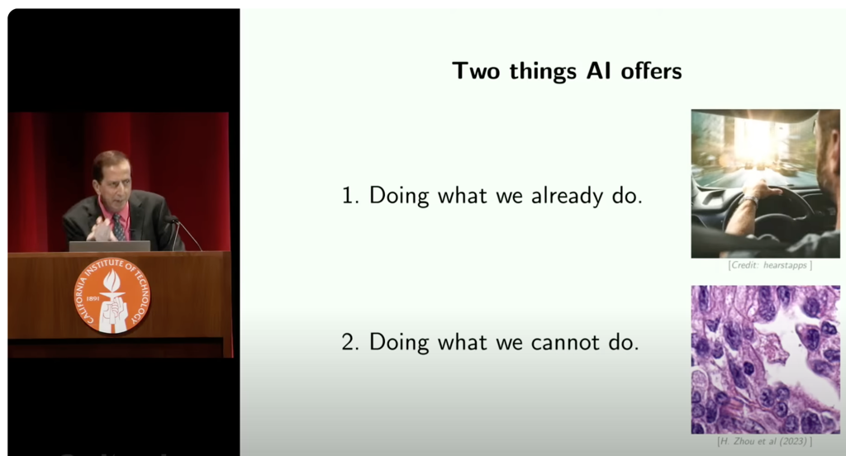

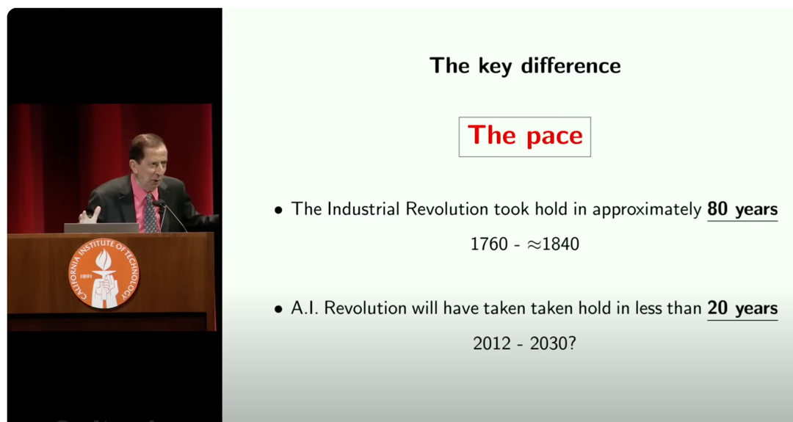

Your Poem about happiness from ChatGPT

Your very hard technical question to ChatGPT: