Lecturer: Dr. Brent Iverson

Teaching Assistants: Brian Ikkanda, Cameron Peebles, Maria Lambousis, Elizabeth Gratton, Christopher Wight

Course Websites: Main resource: http://iverson.cm.utexas.edu/courses/310N/Index.html Canvas: https://utexas.instructure.com/courses/1128463

Active Problem Solving - In response to feedback from former students - Tuesday 3:30-5 PM Room WEL 3.502 New and challenging problems will be presented, and you will work in groups to solve them. All of us will be there to walk around the room and help answer any questions and provide guidance. These optional sessions will provide the perfect opportunity to ask any questions you have about any of the course material as well.

"Missed the Wave" Office Hours - This is back because of popular demand -Wednesday 6-7 PM Room WEL 4.132B This recitation was specifically added for people who feel they need help catching up or want to discuss older material. Brian, the most experienced TA in the department will lead this.

Live Virtual Simulcast Office Hours - Having your questions answered is a huge part of learning Organic Chemistry. Sort of stating the obvious there I know. Unfortunately, in the past attendance at my office hours usually only reached about 20% of the class (or less) most of the time. I am trying something new in order to reach EVERY student with an "office hours" experience-Thursday 5:30-7 PM Click here to watch the live virtual office hour simulcast. We will be taking the questions you submit from your computers and answer them live. This is timed to be the evening before weekly homeworks are due (Fridays). These will be recorded for those of you with conflicts. I want to see how close we can get to having everyone watch the live or recorded sessions. There will be very limited seating available in the broadcast studio, Mez X.XXX, on a first come, first served basis.

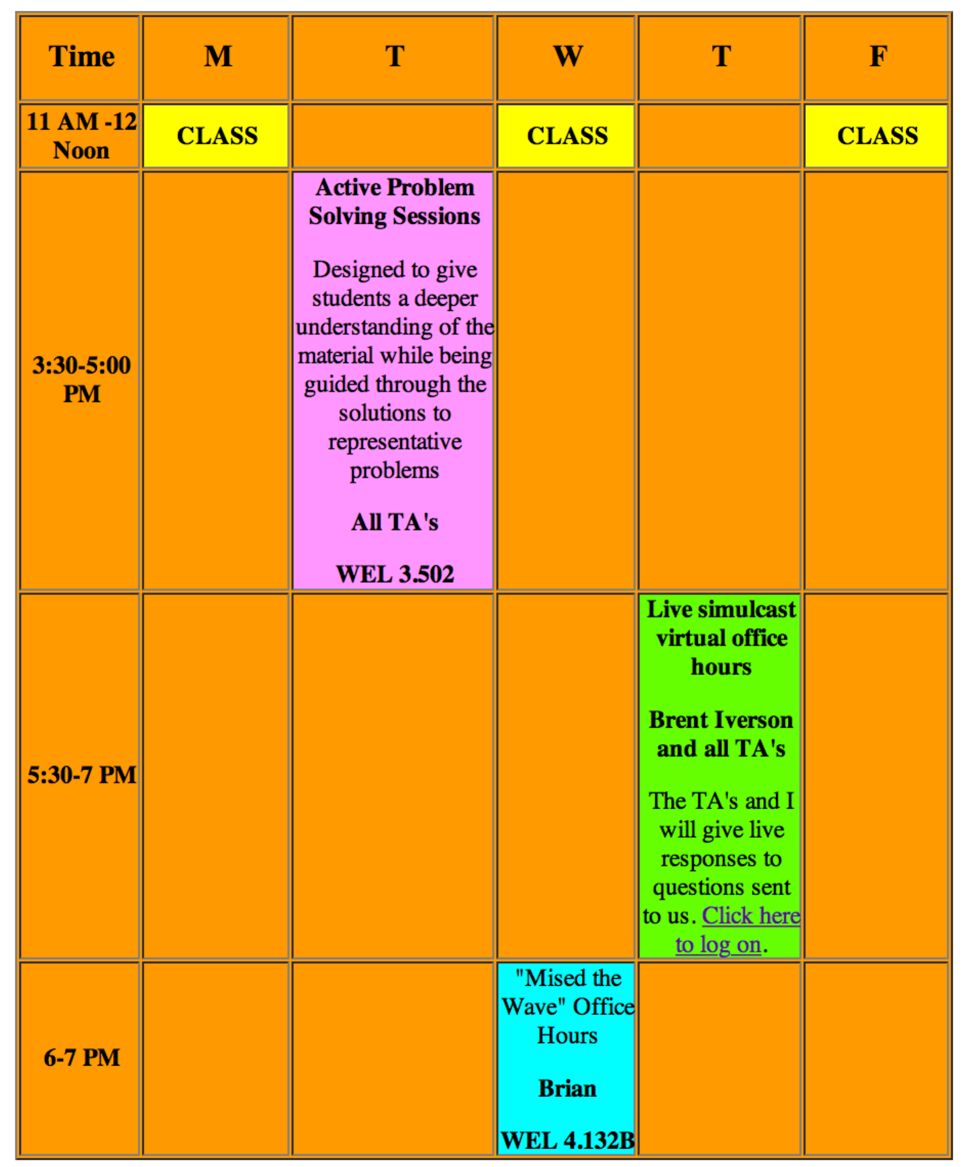

Special Review of 320M/320M material - Wednesday, January 21st, 6-8 PM, WEL 2.224. We have found it helpful to hold a two-hour review at the beginning of the course to review first semester material, with an emphasis on exactly which first semester material is the most important as we begin second semester OChem.

Review Sessions - I will be leading these review sessions which will be designed to help you as much as possible prepare for the exams. Optional review sessions for the mid-term examinations will be given the Monday evening before each exam on the following days and times:

Monday, February 16 Room: WEL 2.224 8:00 - 10:00 PM

Monday, March 23 Room: WEL 2.224 8:00 - 10:00 PM

Monday, April 20 Room: WEL 2.224 8:00 - 10:00 PM

Exams
Three mid-term exams will be given during the course of the semester. They will be held on Thursday evenings from 7:00 - 9:00 PM on the following days:

Thursday, February 19, 7:00 - 9:00 PM, Rooms: UTC 2.112A, BUR 106 Alternate Time (for excused changes only*): 4:00 - 6:00 PM, Room: WEL 3.502 Those of you with last names starting with the letters A-K report to UTC 2.112A, those with last names starting with L-Z report to BUR 106.

Thursday, March 26, 7:00 - 9:00 PM, Rooms:UTC 2.112A, BUR 106 Alternate Time (for excused changes only*): 4:00 - 6:00 PM, Room: WEL 3.502 Those of you with last names starting with the letters A-K report to UTC 2.112A, those with last names starting with L-Z report to BUR 106.

Thursday, April 23, 7:00 - 9:00 PM, Rooms: WEL 2.224 (NOTE THE CHANGE IN ROOM), BUR 106 Alternate Time (for excused changes only*): 4:00 - 6:00 PM, WEL 3.502 Those of you with last names starting with the letters A-K report to WEL 2.224, those with last names starting with L-Z report to BUR 106.

*An excused change is one caused by a regularly scheduled (in the course schedule) class or lab class. NOT an organization meeting, music practice or a job. If you have any unexcused conflicts, it is up to you to arrange to be present at the mid term exams from 7-9 PM (That is why the dates are published in the course catalogue)

Final Exam: Wednesday, May 13, 9:00 AM - noon Rooms: TBA

Policy on Exam Coverage: You will be responsible for all material covered up to the Friday lecture the week before each midterm. That way you will be able to think about the material for almost an entire week before you are tested on it. Also, the pace of the class can vary, so do not be concerned if we are not on the same schedule as descibed below under "proposed exam topics". The bottom line is that you are only responsible for the material covered in the previous Friday's lecture, NO MATTER WHAT THE SCHEDULE IN THE SYLLABUS SAYS ABOUT "UNITS" COVERED ON EACH MIDTERM

