Here are some WRONG Answers:
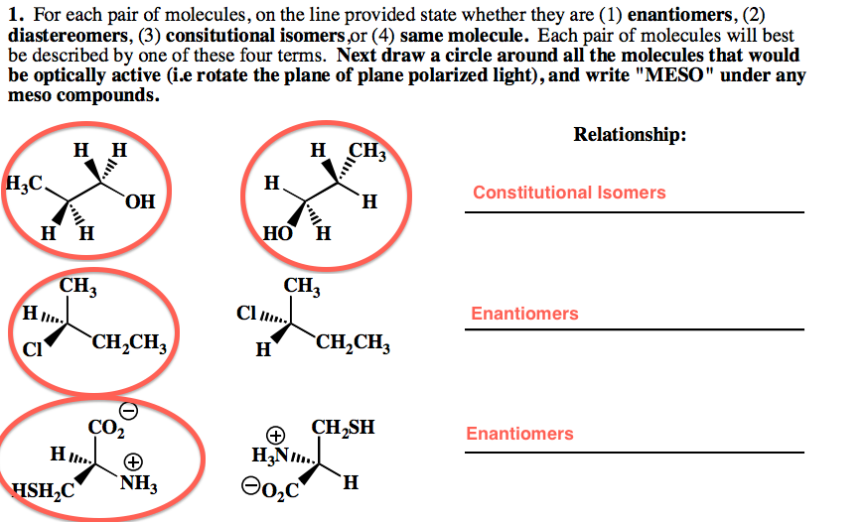

1. Just because the first two molecules are drawn in different perspectives, you cannot assume they are different constitutional isomers.
2. Although these are enantiomers of each other, these questions are not assuming these are a mixture of molecules, i.e. racemic (it is asking if each individual molecule is optically active), so please circle BOTH chiral molecules.
3. These two are NOT enantiomers even though groups are switched around. You have to flip the molecule and then rotate it in order to see that they are the same molecule. (also, if you swap two substituents with each other, and then swap the other two substituents, then you end up with the same molecule!)

Here is the CORRECT answer
